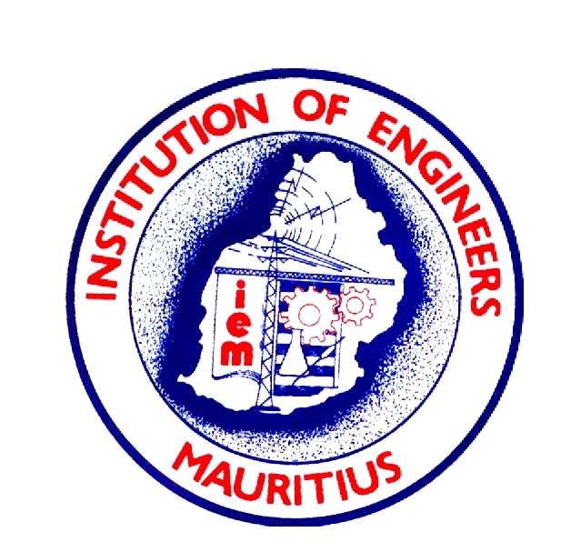
Message from President of the Institution of Engineers Mauritius
Eng. Raj H Prayag GOSK.PDSM. PEng (IEM) CEng. FIEM

Dear Fellow Member of IEM

I am very pleased to touch base with you regarding some excellent news about our profession first and then about some of the activities of our Institution.
Let me recall that our visionary IEM founders in 1948 had the foresight of creating IEM to represent the engineering profession and provide a forum for all engineers to come together for the advancement of the engineering profession, irrespective of the engineering disciplines in which they specialised or practised, and had set itself the objectives: to foster engineering science and its application in all engineering disciplines, ensure the highest standard of service in engineering to the community.
That was 76 years ago. Since then, much has changed, as has the world, and today, we are faced with unprecedented challenges on many fronts: economic, geopolitical and as far as we are concerned from Climate Change. The model of development of our island needs to be challenged.
Because of the above, the Council of IEM decided that we needed a new breed of Engineers, who can solve complex problems and problems as yet, unknown to man. In this context and with a view for Engineers to stay relevant and to continue providing a service to mankind, in June 2017, the IEM Council had decided to embrace an international (outcome-based education) standard of engineering education for professional engineers, with proven technical knowledge and skill as benchmarked by the Washington Accord (WA).
IEM with the help of some volunteers, senior engineers, had worked very hard since then and we are pleased to inform you that after having satisfied all the criteria for provisional membership of WA, including preparing a governance manual, 12 documents on policy and guidance, criteria, standards of programs, self-study, procedure for appeal, visit team report, amongst others, accreditation visits to two universities to accredit 4 programs in the presence of two observers from National Board of Accreditation of India and the Engineering Council of South Africa, we uploaded our application for provisional membership on 8th February 2024.
This date of 8th February 24 will hereafter be a historical date as IEM has broken through the glass ceiling.
To put it.in a global perspective, there are 54 countries on our African Continent, only South Africa is a signatory of Washington Accord. Nigeria, one of the largest and richest country in Africa with a population of 218,541,212 became a provisional member of WA in June 23. IEM’s application for provisional membership, supported by NBA and ECSA will be considered at the June 24 International Engineering Alliance meeting in New Delhi. We should become the third African Country to be a member of WA, a global reference. There will be huge advantages to graduates with a WA accredited degree. It will provide mutual recognition in other signatory members States and provide opportunities and mobility.
This achievement will greatly boost the reputation of our Universities to deliver Engineering Degree Programs of the highest standard and greatly enhance the reputation of Mauritian Engineers at global level.
I thank and recognize all those Engineers who have participated in this project for their dedication, voluntarism, and patriotic effort to raise the profile of Mauritius. I must name the two champions Dr. Andre Chan Chin Yuk and Mr Jagadish Soobarah for their unparallel leadership and hard work to see the project through.
I also thank the Vice Chancellor, the Dean and staff of the Faculty of Engineering of the University of Mauritius, Likewise, I thank the Director General of the University of Technology, the Head of the Engineering Faculty and staff for their full collaboration, which involved much hard work.
The IEM’s Engineering Accreditation Board will be the undisputed accreditor of engineering degree programs for Washington Accord and within the jurisdiction of the Republic of Mauritius.
On 1st March 2024, we are having our AGM at the IEM house and I am requesting you to please attend this annual meeting to show your appreciation and honour those tens of engineers from both academia and industry who have worked hard on our behalf, to take our profession to the highest level of recognition beyond our shores.
I also implore you to please consider stepping up and come and join the IEM council as an active member to serve and help enhance our profession to yet another level of excellence through innovation. It is time to give back to the profession what the profession has given to you.
We need serious, motivated, selfless and competent persons with leadership qualities to serve and to lead IEM to its next goal of full membership of WA by June 2026.
The Outgoing Council has laid the foundation, and we need YOU to take IEM forward as the next two years will require much hard work to become a full signatory of the Washington Accord and to provide accreditation services to all public and private universities operating in Mauritius.
IEM also needs to provide support, guidance and training to our young graduates and assist in grooming the new generation of Future Engineers, thinkers, and solvers of complex problems. We need senior Engineers to care and run CPD courses in order to provide ongoing continuous training to all engineers. Hopefully CRPE will in the near future will consider CPD courses as a criteria for renewing the yearly registration, as are being done by other professional bodies.
Finally, I thank you all for providing me with the privilege of having lead IEM, as its President since 2017.

I have delivered on two fronts: (1) We are at the doorstep of Washington Accord. We have applied to become a provisional member of WA in June 2024 having built support at National and intercontinental levels and (2) We have built credibility at the Africa Continental level to have been elected as the President Elect of the Southern African Federation of Engineering Organisation (SAFEO), comprising of eleven countries. IEM will take over in October 2024 and our African Colleagues are expecting much in terms of leadership, innovation, experience sharing and driving subregional projects to serve our communities made up of people with different languages and cultures. I am convinced that we have the maturity, the experience and the leadership qualities to lead the Sub-region.
The future is bright. Let us go forth together and deliver.
Long live IEM

Eng. Raj H Prayag, GOSK, PDSM, PEng(IEM) CEng. FIEM
President, Institution of Engineers Mauritius
21.02.2024

